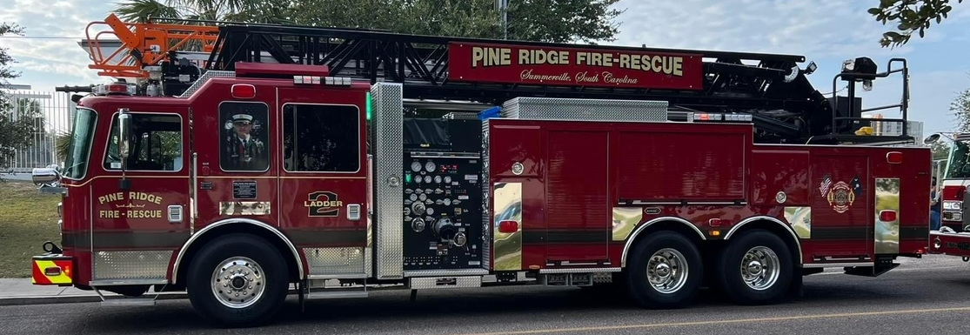

**PINERIDGE FIRE DEPARTMENT**

**IS HIRING**

**ENGINEER – FULL TIME**

**Minimum qualifications include IFSAC FF2 Certification; IS 300; Current CPR/First Aid (EMR preferred); Auto Extrication; Pump Ops 1 and 2; Incident Safety Officer; Aerial Operations.**

**Starting rate for this position is $15.30/hour or $44,676 per year, base wages.**

**Benefits include Employee Health Insurance, SC PORS, and Vacation/PTO.**

**For more information visit**

**https://www.pineridgefd.org/membership-opportunities**

**Pine Ridge Fire Department is an equal opportunity employer.**